Bash scripting 2nd Task
- Create a bash script to check if a directory is available or not.
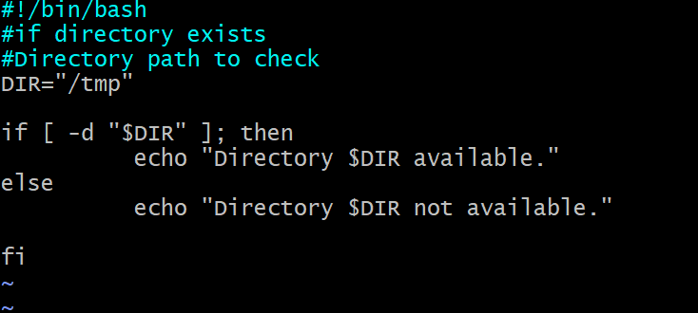

- Create a bash script to create multiple files.
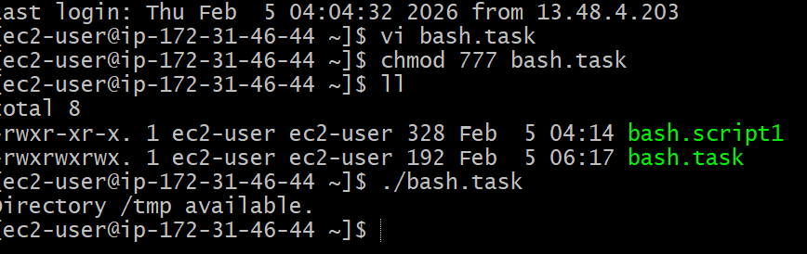
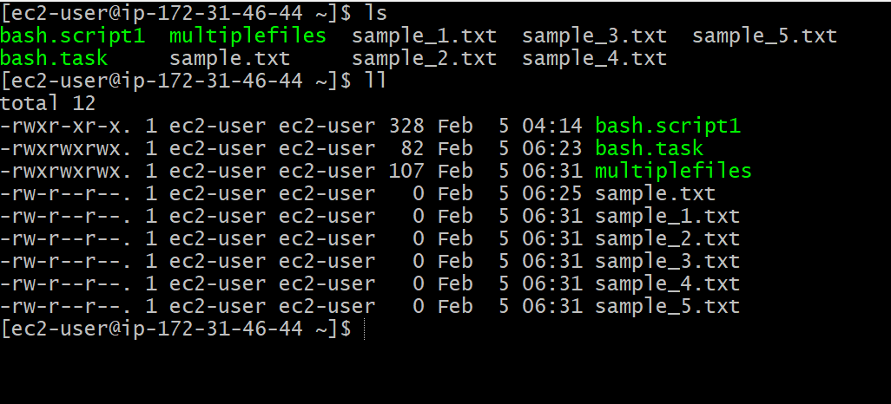
- Create a bash script to take a backup of a directory.
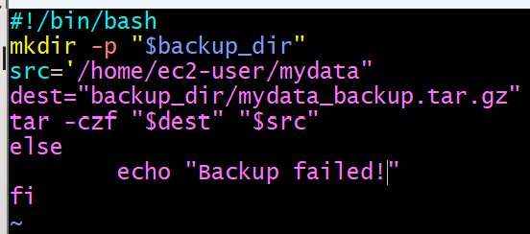

- Create a bash script to install Nginx on an EC2 server
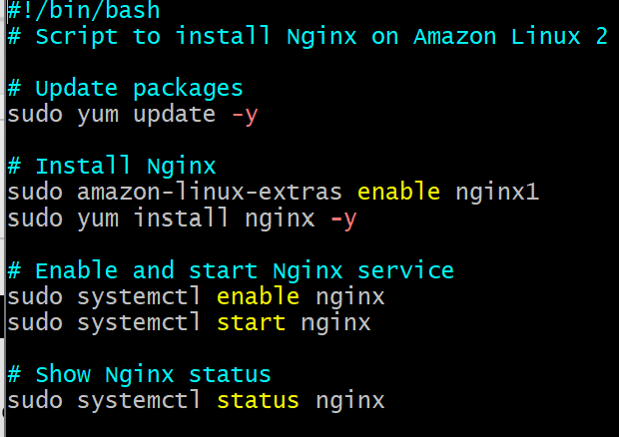
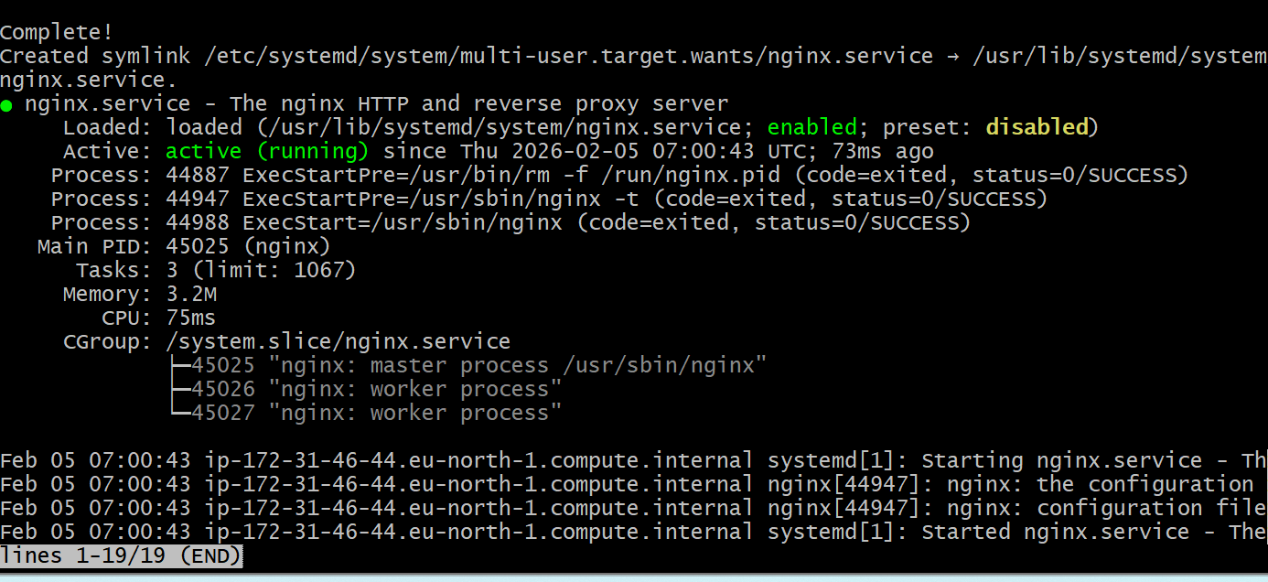

- Create a bash script to install Apache Tomcat on an EC2 server.
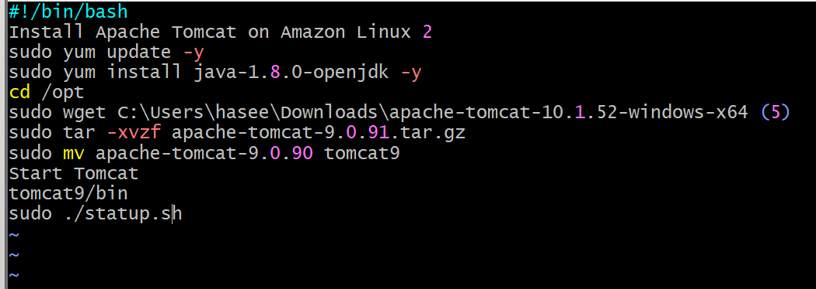
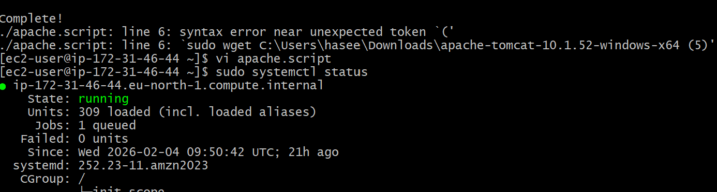

- Create a bash script to check if the Nginx service is running, if not running then script should start the service.
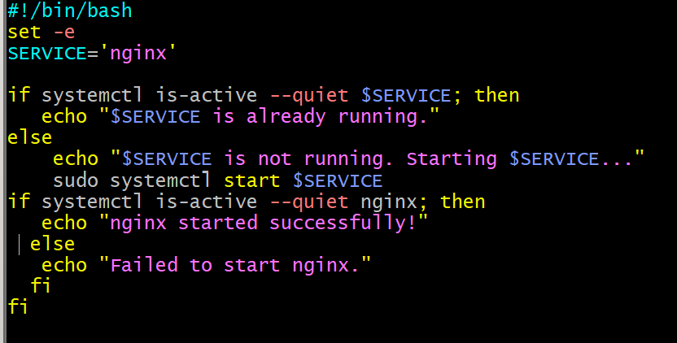
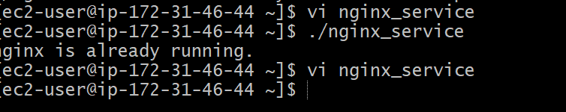

- Create a bash script for a calculator.
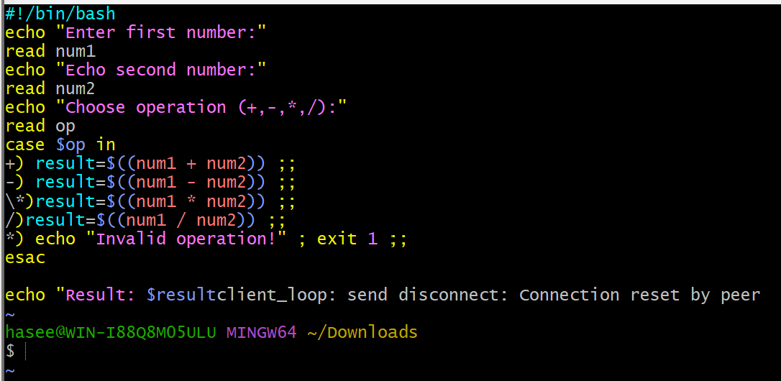
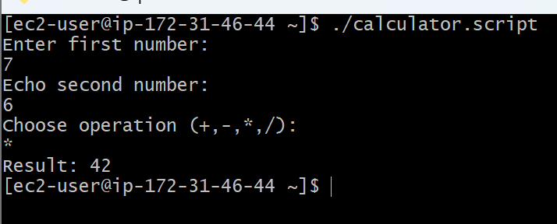

- Create a bash script to check if a directory exists, if not then create a directory.
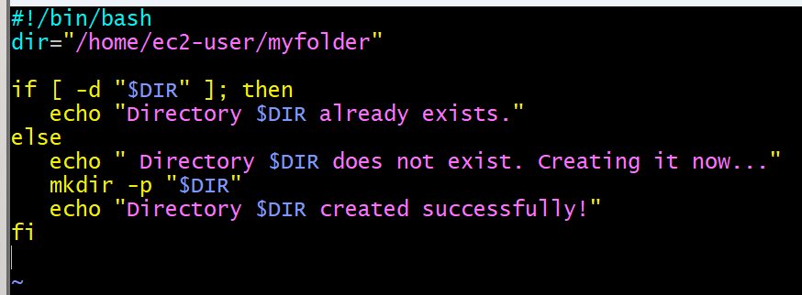
- Create a bash script to delete the last 3 lines of a file
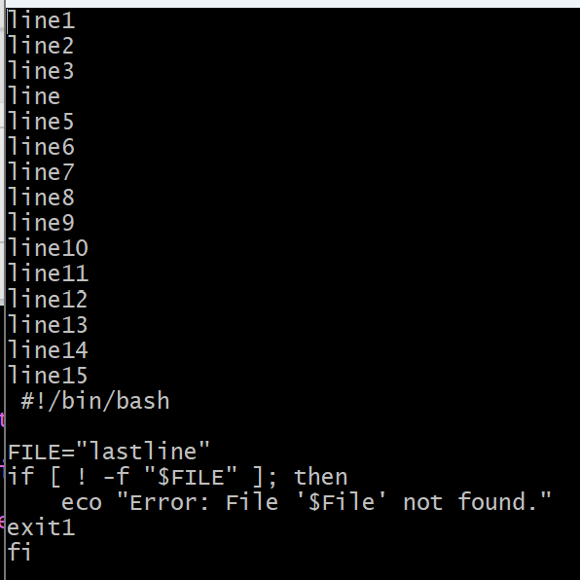

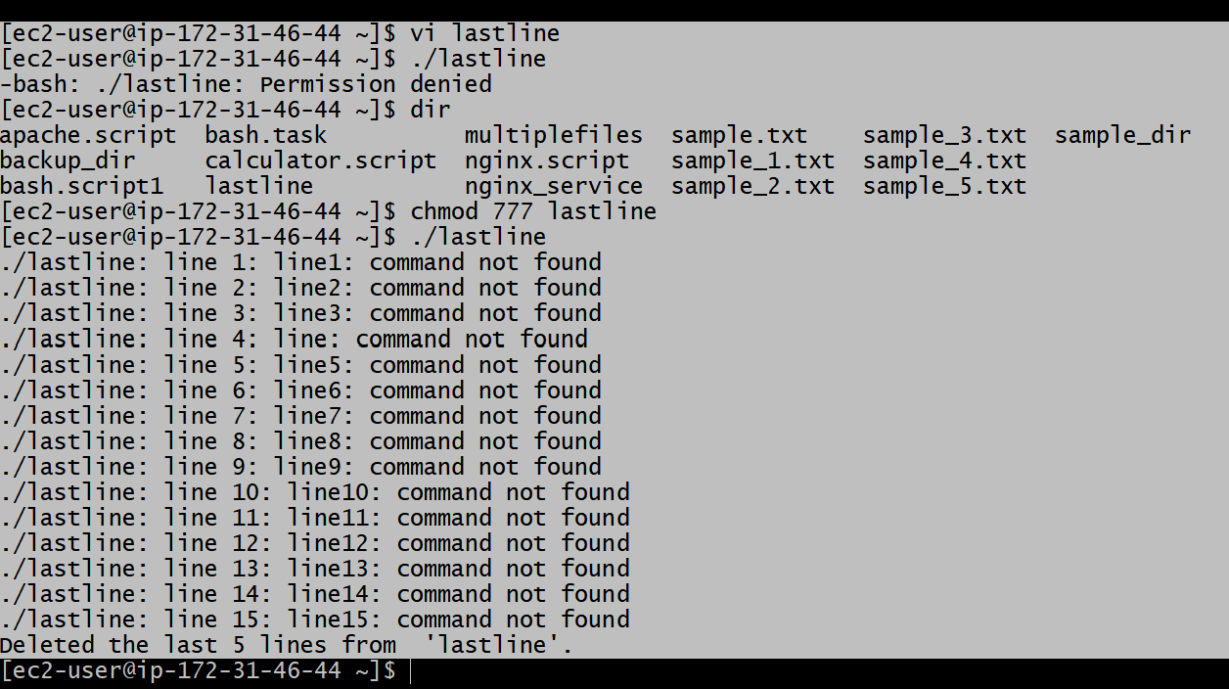

- Bash script to monitor cpu and if it is more than 80% then send email
notification.
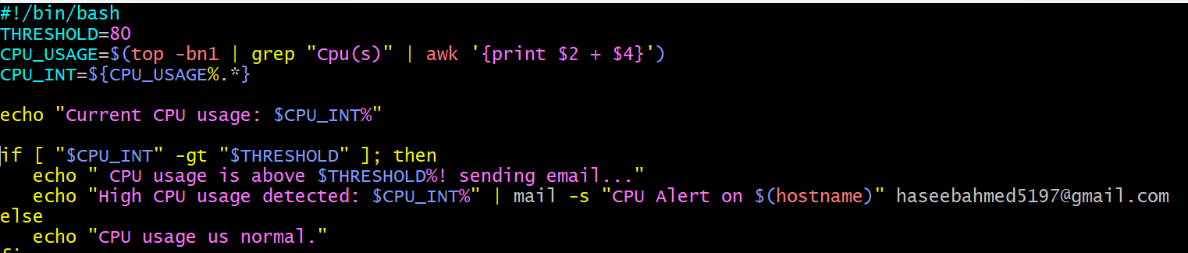
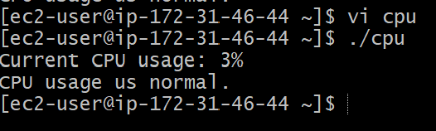

- Bash script to monitor disk space and if it is more than 80% then send email notification.

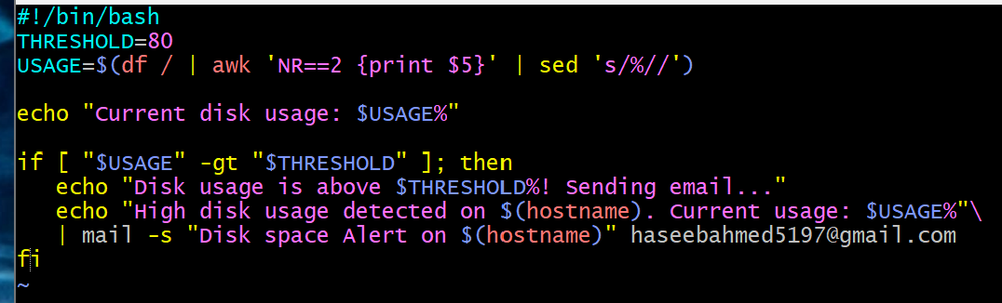
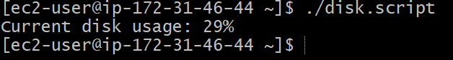

- Bash script to monitor memory and if it is more than 80% then send email notification
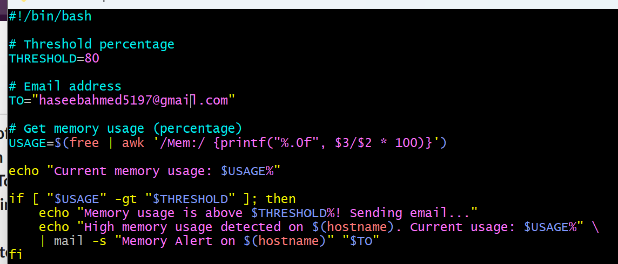
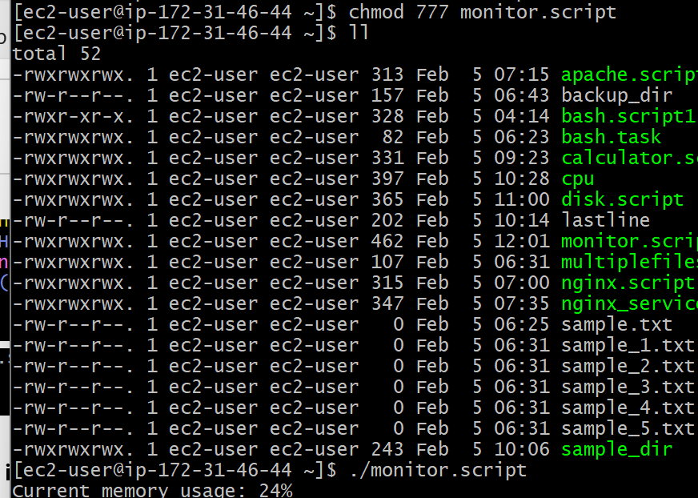

Crontab

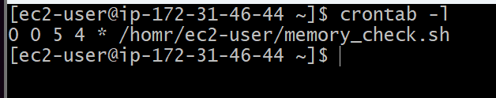

Every midnight
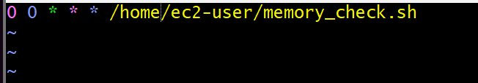

Every weekend (Saturday night 11:59pm)

After every reboot

